**Final Project Report**

**NLP Chatbot Development Using Dialogflow**



**Project Supervisor**

Abdullah Qamar

**Submitted By**

F24PROJECT9A4A9

Imtanan Ahnaf BC200401263

**Software Projects & Research Section,**

**Department of Computer Sciences,**

**Virtual University of Pakistan**

|  |
| --- |
|  |



**CERTIFICATE**

This is to certify that Imtanan Ahnaf (BC200401263) has worked on and completed their Software Project at Software & Research Projects Section, Department of Computer Sciences, Virtual University of Pakistan in partial fulfillment of the requirement for the degree of BS in Computer Sciences under my guidance and supervision.

In our opinion, it is satisfactory and up to the mark and therefore fulfills the requirements of BS in Computer Sciences.

**Supervisor / Internal Examiner**

Abdullah Qamar

Supervisor,

Software Projects & Research Section,

Department of Computer Sciences

Virtual University of Pakistan

___________________

(Signature)

**External Examiner/Subject Specialist**

<<External Supervisor Name>>

___________________

(Signature)

**Accepted By:**

**_____________**

(For office use)

**EXORDIUM**

**In the name of Allah, the Compassionate, the Merciful.**

**Praise be to Allah, Lord of Creation,**

**The Compassionate, the Merciful,**

**King of Judgment-day!**

**You alone we worship, and to You alone we pray for help,**

**Guide us to the straight path**

**The path of those who You have favored,**

**Not of those who have incurred Your wrath,**

**Nor of those who have gone astray.**

**DEDICATION**

**I dedicate this project to everyone who has played an important role in helping me reach this milestone.**

**Firstly, to my family—your constant love, support, and encouragement have been my greatest strength. Your faith in me has motivated me to keep going and give my best, even in tough times.**

**To my professors and mentors, thank you for your guidance, knowledge, and patience. Your efforts in creating a positive learning environment have helped me grow both academically and personally.**

**To my friends and classmates, I’m grateful for your support, teamwork, and all the good memories we created together during this journey. You made this experience enjoyable and meaningful.**

**Finally, I dedicate this work to the many teachers and educational staff who work hard every day to improve education. I hope this NLP Chatbot Development using Dialogflow can help make their work a little easier and their institutions more efficient.**

**Thank you all for being part of this journey and for your continued inspiration.**

**ACKNOWLEDGEMENT**

**I would like to sincerely thank all those who supported and guided me during the completion of my Final Year Project, “NLP Chatbot Development using Dialogflow.”**

**First and foremost, I express my deep gratitude to my supervisor, Mr. Abdullah Qamar, for his valuable guidance,constant encouragement, and thoughtful feedback throughout this project. His expertise and suggestions played a vital role in shaping the direction and**

**outcome of my work.**

**I am especially thankful to my family, whose continuous support, love, and patience kept me motivated throughout this journey. Their belief in my abilities helped me stay focused and overcome every hurdle.**

**My heartfelt thanks also go to the faculty and staff of the Department of Computer Science & IT, Virtual University of Pakistan, for providing a strong academic foundation and a supportive learning environment.**

**To my friends and fellow students, thank you for your collaboration, helpful discussions, and moral support. Sharing this experience with you made the process more meaningful and enjoyable.**

**Lastly, I acknowledge everyone—whether directly or indirectly—involved in the successful completion of this project. Your contributions, big or small, have all been appreciated.**

**Thank you all for being part of this journey.**

**PREFACE**

The completion of this Final Year Project, titled “NLP Chatbot Development using Dialogflow,” marks a significant milestone in my academic journey. The primary objective of this project was to develop a smart and interactive chatbot tailored for a training company, aimed at automating customer support and handling user queries through natural language processing. The system leverages Dialogflow's NLP capabilities to simulate human-like conversations and assist users efficiently.

**Motivation and Rationale:** The idea for this project originated from the common challenges faced by training institutes in managing frequent inquiries related to course details, schedules, registrations, and support. Manual handling of such queries can be time-consuming and prone to delays. Recognizing the growing importance of automation in the education and training sector, I was motivated to design a solution that could respond instantly and accurately to user questions, ultimately enhancing user experience and reducing the administrative burden.

**Methodology:**  
 To accomplish the project’s goals, I adopted a structured approach that involved requirement analysis, chatbot intent design in Dialogflow, and system integration with a web-based platform. The user interface was built using HTML, CSS, and JavaScript, while PHP and MySQL were used to implement user authentication and role-based access. The project was developed and refined in phases, with regular testing and validation. I am grateful for the continuous guidance and support of Mr. Abdullah Qamar, whose mentorship played a crucial role in the development process.

**Scope and Significance:** The NLP Chatbot for Training Company is capable of handling a wide range of queries such as course information, registration procedures, class schedules, and general support. It features a role-based system for users and admins, making it secure and manageable. The chatbot not only improves responsiveness but also ensures consistency in information delivery. Its scalable design makes it adaptable for use in other educational or service-based organizations looking to automate their support systems.

**Conclusion:**  
 This project gave me the opportunity to apply my technical knowledge to solve a real-world problem. It helped me gain valuable experience in chatbot development, NLP, backend integration, and system design. I believe this chatbot system can provide significant value to training companies and similar institutions. I hope it serves as a useful reference for future enhancements in the field of AI-driven support solutions.

**TABLE OF CONTENTS**

|  |
| --- |
|  |

CHAPTER NO. 1

gathering & Analyzing info 10

1.1 Introduction

1.2 purpose

1.3 scope

1.4 definitions, acronyms and abbreviations

1.5 use cases and usage scenarios

1.5.1 Use Case Diagrams

1.5.2 Usage Scenarios

1.6 supplementary requirements

1.6.1 Usability

1.6.2 Reliability

1.6.3 Supportability

1.6.4 System Requirements

CHAPTER NO. 2

planning the project 11

2.1 Introduction

2.2 Available Methodologies

2.3 Chosen Methodology

2.4 Reasons for Chosen Methodology

2.5 Work Plan

CHAPTER NO. 3

designing the project 12

3.1 Introduction

3.2 purpose

3.3 scope

* 1. definitions, acronyms and abbreviations
  2. Dynamic Model: Sequence Diagrams
  3. Object Model/Logical Model: Class Diagram
  4. Database Model (Database Diagram)
  5. Graphical User Interfaces

3.9 Intents Structure

Chapter no.4

DEvelopment 13

4.1 Development plan (Architecture Diagram)

**<<Dear Students, you must take special care of page numbers, which are written against each Chapter and sub headings. You have to mention your own page numbers and correct one against each document heading. Make proper table of contents. Remember that if there are any new headings or you have included more headings in your documents then you also must write these in table of contents and modify table of contents according to your document’s material>>**

**<<Dear Students, before starting each chapter the following would be the title page for each chapter on a separate page>>**

**CHAPTER 1**

Gathering & Analyzing Info

### **1.1 Introduction**

This project focuses on building an AI-based chatbot for a **Training Company** using **Google Dialogflow**. The chatbot aims to automate and handle student inquiries, course registration, schedule details, and resource distribution. By using Natural Language Processing (NLP), the chatbot will provide a smooth and quick interaction system for both students and administrators, helping save time and improving services.

### **1.2 Purpose**

The purpose of this report is to describe how the chatbot system is planned, designed, and developed. The main goal of the system is to:

* Automate routine tasks like answering course-related questions.
* Make registration and scheduling easier for students.
* Support admin in managing course catalogs and FAQs.
* Improve communication between students and the training company using AI tools.

This document will act as a complete guide throughout the development process.

**1.3 Scope:**

The primary purpose of the project is to develop an AI-powered chatbot specifically for a Training Company. This chatbot will streamline and automate various administrative tasks and student interactions, providing an efficient and user-friendly platform for handling inquiries. By leveraging Google DialogFlow’s advanced NLP capabilities, the chatbot aims to improve operational efficiency and enhance the user experience for students, staff, and prospective enrollees.

### **1.4 Definitions, Acronyms, and Abbreviations**

|  |  |
| --- | --- |
| Acronym | Definition |
| SRS | Software Requirements Specification |
| NLP | Natural Language Processing |
| AI | Artificial Intelligence |
| UI | User Interface |
| UX | User Experience |
| FAQ | Frequently Asked Questions |
| SSL | Secure Sockets Layer – A security protocol |
| Dialogflow | A platform by Google to build conversational interfaces |
| Bot | Short form of chatbot – an AI-based program that simulates conversation |

**Please turn to the next page:**

**1.5 use cases and usage scenarios**

**1.5.1 Use Case Diagrams**

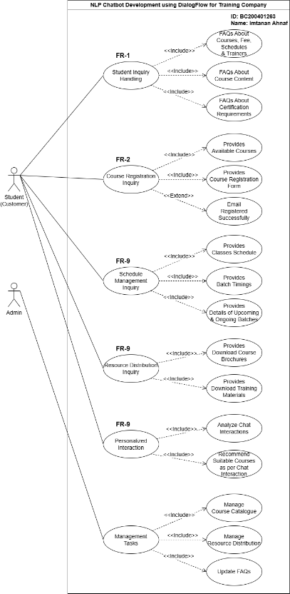

**1.5.2 Usage Scenarios**

|  |  |
| --- | --- |
| **FR ID:** | **FR-01** |
| **Use Case Title:** | Student Inquiry Handling |
| **Use Case Id:** | UC-01 |
| **Actor:** | Student (Customer) |
| **Actions:** | 1. User asks an inquiry. 2. Chatbot retrieves FAQs. 3. Chatbot provides a relevant response. |
| **Description:** | The chatbot answers FAQs related to courses, fees, schedules, trainers, content, and certification requirements. |
| **Alternative Paths:** | User may refine or rephrase their query if the chatbot does not initially find a match. |
| **Pre-Conditions:** | User has access to the chatbot interface. |
| **Post Conditions:** | User receives an accurate response. |
| **Exception:** | Chatbot fails to find an answer due to incomplete FAQs or incorrect query interpretation. |
| **Author:** | BC200401263 |

|  |  |
| --- | --- |
| **FR ID:** | **FR-02** |
| **Use Case Title:** | Course Registration Inquiry |
| **Use Case Id:** | UC-02 |
| **Actor:** | Student (Customer) |
| **Actions:** | 1. User views course catalog. 2. User selects a course. 3. Chatbot provides a registration form. |
| **Description:** | Allows students to register for available courses, completing the process with email confirmation. |
| **Alternative Paths:** | User may choose another course after viewing the catalog. |
| **Pre-Conditions:** | Courses are available and updated in the catalog. |
| **Post Conditions:** | User successfully registers for a course and receives a confirmation. |
| **Exception:** | Registration fails if required fields are incomplete or if there is a technical issue. |
| **Author:** | BC200401263 |

|  |  |
| --- | --- |
| **FR ID:** | **FR-03** |
| **Use Case Title:** | Schedule Management Inquiry |
| **Use Case Id:** | UC-03 |
| **Actor:** | Student (Customer) |
| **Actions:** | 1. User asks about schedule. 2. Chatbot provides class details, timings, or batch statuses. |
| **Description:** | Students can inquire about ongoing/upcoming class schedules, batch timings, or statuses. |
| **Alternative Paths:** | User can request details of a different class or batch if needed. |
| **Pre-Conditions:** | Schedule information is available in the system. |
| **Post Conditions:** | User gets accurate schedule details. |
| **Exception:** | Details cannot be retrieved due to missing or outdated schedule data. |
| **Author:** | BC200401263 |

|  |  |
| --- | --- |
| **FR ID:** | **FR-04** |
| **Use Case Title:** | Resource Distribution Inquiry |
| **Use Case Id:** | UC-04 |
| **Actor:** | Student (Customer) |
| **Actions:** | 1. User requests materials. 2. Chatbot provides links for download. |
| **Description:** | The chatbot enables students to download course brochures or training materials. |
| **Alternative Paths:** | User can try downloading alternate resources if initial selection fails. |
| **Pre-Conditions:** | Resources are uploaded and available in the system. |
| **Post Conditions:** | User successfully downloads requested resources. |
| **Exception:** | Resources unavailable or downloads fail due to server or file issues. |
| **Author:** | BC200401263 |

|  |  |
| --- | --- |
| **FR ID:** | **FR-05** |
| **Use Case Title:** | Personalized Interaction |
| **Use Case Id:** | UC-05 |
| **Actor:** | Student (Customer) |
| **Actions:** | 1. User interacts with chatbot. 2. Chatbot analyses interaction. 3. Chatbot suggests courses. |
| **Description:** | The chatbot recommends suitable courses based on interaction history or specific inquiries. |
| **Alternative Paths:** | User may ignore the chatbot's recommendation and explore the course catalog manually. |
| **Pre-Conditions:** | User provides enough interaction data for analysis. |
| **Post Conditions:** | User receives personalized course suggestions. |
| **Exception:** | Recommendation fails if user data is insufficient or interaction history is incomplete. |
| **Author:** | BC200401263 |

|  |  |
| --- | --- |
| **FR ID:** | **FR-06** |
| **Use Case Title:** | Management Tasks |
| **Use Case Id:** | UC-06 |
| **Actor:** | Admin |
| **Actions:** | 1. Admin logs in. 2. Admin performs tasks like managing course catalog, FAQs, or resources. |
| **Description:** | The chatbot answers FAQs related to courses, fees, schedules, trainers, content, and certification requirements. |
| **Alternative Paths:** | Admin can manage the course catalog, upload/download training materials, and update FAQs for improved system responses. |
| **Pre-Conditions:** | Admin may choose to delegate specific tasks (e.g., uploading brochures) to a subordinate. |
| **Post Conditions:** | System is updated with new courses, FAQs, and resources. |
| **Exception:** | Changes fail to save due to incorrect inputs or system errors (e.g., server downtime). |
| **Author:** | BC200401263 |

**1.6 Supplementary Requirements**

**1.6.1 Usability**

**Requirement**: The chatbot shall offer an intuitive, user-friendly interface accessible to both students and administrative staff without the need for technical training.

**Actions:**

* Use simple language and conversational tone for chatbot replies.
* Design chatbot flows to guide users step-by-step for course registration, schedule checking, and FAQs.
* Test the interface with real users (students and staff) and adjust based on feedback.
* Ensure compatibility across desktop, tablet, and mobile devices.

**1.6.2 Reliability**

**Requirement:** The chatbot shall maintain an uptime of 99.9%.

* **Action:** Monitor system performance and implement automatic error recovery mechanisms.

**1.6.3 Supportability**

#### 

* **Requirement:** The system shall be easy to update, extend, and debug by future developers or the internal IT team.

**Actions:**

* Implement modular and well-documented code for both backend and DialogFlow intents.
* Provide admin access for updating FAQs, course information, and downloadable resources without needing developer involvement.
* Maintain version control using GitHub with clear commit messages and a README file for guidance.
* Create a brief admin manual or support document outlining how to manage content and handle common issues.

**1.6.4 System Requirements**

**Client-Side Requirements:**

* Modern web browser (Chrome, Firefox, Edge) with JavaScript enabled.
* Internet connection to access the chatbot hosted online.

**Server-Side Requirements:**

* Hosting platform that supports PHP (for backend) and MySQL database.
* DialogFlow integration with API access enabled.
* SSL Certificate for secure HTTPS connection.
* Other Dependencies:
* Google Cloud Account with DialogFlow ES or CX enabled.
* PHP version 7.x or higher.
* MySQL version 5.7 or higher.

**CHAPTER 2**

Planning the Project

**2.1 Introduction**

Effective planning is a crucial foundation for the successful execution of any software project. In this project, which involves the development of an NLP-based chatbot using Google Dialogflow, careful planning ensures that all phases—from requirement gathering to deployment—are carried out efficiently. The chatbot is aimed at automating and improving user interactions for a selected industry (Training Company, Pharmacy Store, or Restaurant), and proper planning will help align the development process with the project goals. This includes selecting appropriate tools, assigning tasks, setting timelines, identifying risks, and establishing checkpoints to monitor progress. With clear objectives and a structured approach, the project team can deliver a high-quality, user-centric solution that meets the expectations of both end-users and stakeholders.

**2.2 Available Methodologies**

Several software development methodologies can be used to manage and execute projects like this AI-powered chatbot. Each has its own process flow, strengths, and limitations. Below are the commonly used methodologies:

**1.Waterfall Model**

A linear and sequential approach. Each phase (requirements, design, development, testing, deployment) is completed before the next begins.

**Pros**: Simple, easy to manage.

**Cons**: Not flexible; changes are hard to make after a phase ends.

**2.Agile Model**

An iterative approach that breaks the project into small cycles called sprints. Regular feedback and continuous improvements are part of the process.

**Pros:** Flexible, supports frequent updates and feedback.

**Cons:** Requires active user involvement and strong team collaboration.

**3.Spiral Model**

Combines iterative development with risk analysis. The project is developed in cycles (spirals), with repeated refinements.

**Pros:** Good for high-risk projects.

**Cons:** Complex and costly.

**4.V-Model (Validation & Verification Model)**

Similar to Waterfall, but every development phase has a corresponding testing phase.

**Pros:** Emphasizes testing and quality.

**Cons:** Rigid, not ideal for changing requirements.

**5.Rapid Application Development (RAD)**

Focuses on quick development and user feedback using prototypes.

**Pros:** Fast development, user-focused.

**Cons:** May compromise quality if rushed.

**2.3 Chosen Methodology**

Methodology is a framework that is used to structure control and process of developing information system. **The chosen methodology is “VU process model”**. VU process model is a combination of Water Fall model and Spiral model.

* **Water Fall Model:**

This model is also known as linear sequential model because of starting with one stage then onto the next. This model is known as Water Fall model.

Water fall model is depicted in following diagram.

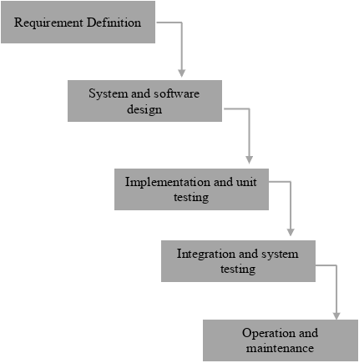

It recommends a systematic, sequential approach to software development that begins at system level and progresses through the analysis, design, coding, testing and maintenance. No phase is complete until the documentation for that phase has been complete.

* **Spiral Model:**

Spiral model is Water Fall model with risk analysis. In that case each stage is preceded by identification of alternatives and risk analysis, and is then followed by evaluation and planning for next phase.Spiral model is depicted in following diagram.

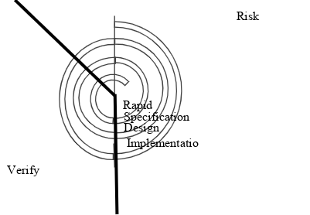

**VU Process Model:**

Having detailed knowledge of Water Fall model and Spiral model, and keeping in view nature of my project, I choose VU process model that is the combination of Water Fall model and Spiral model. It explains the simplified description of software processes in iteration to avoid maximum risk, Both spiral and water fall methods combine to develop a hybrid approach of system development that maximize the quality of the system and minimizes the risk and disadvantages to enhance the results of the system.

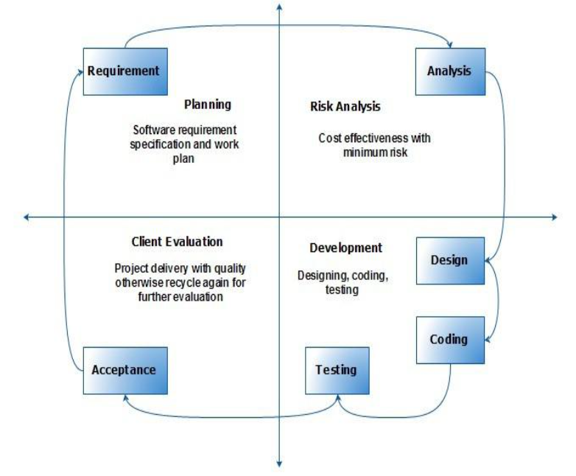

**2.4 Reasons for chosen Methodology**

VU Process model has benefits of probability from the signs-based planning of Water Fall model as well as the benefit of feedbacks and creativity from Spiral model, so there are some following reasons.

* The VU process model is documentation- driven model. It therefore generates complete and comprehensive documentation and hence makes the maintenance much easier.
* VU process model works on phases so it is better to complete our project. It is sequential Model with backward repetition
* All activities are performed in sequence in vu process model.
* Another reason for choosing vu process model is we can do correction or maintenance at any stage whenever necessary.

**2.5 Work Plan**

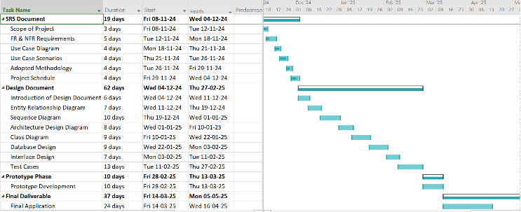

**CHAPTER 3**

Designing the Project

**3.1 Introduction**

The design phase of the NLP Chatbot Development using Dialogflow for the Training Company marks a pivotal stage in transforming gathered requirements into a structured technical solution. This phase involves creating a comprehensive design document that outlines the system’s structure, functionality, and interaction flows. It acts as a blueprint for the development team, ensuring that all technical components align with the project goals and user needs. By translating abstract ideas into detailed models such as ER diagrams, architecture diagrams, and interface designs, the design document helps streamline the implementation process.

**3.2 Purpose**

The purpose of the design phase is to provide a clear and organized representation of how the chatbot system will function, both internally and externally. It helps developers, designers, and testers visualize the entire system before coding begins. By doing so, it minimizes ambiguity, reduces development risks, and ensures that the final product fulfills all specified requirements effectively. Moreover, it sets a strong foundation for achieving technical consistency and functional correctness throughout the project lifecycle.

**3.3 Scope**

This design documentation covers all essential elements needed to construct the chatbot system for a Training Company. It includes the definition of system components such as database structure (ERD), class diagrams, interaction flows (sequence diagrams), system architecture, user interfaces, and test cases. The scope extends to illustrating how users like students and administrators will interact with the chatbot, how data will flow between system components, and how the system will manage queries and course-related functions. The design ensures scalability, maintainability, and a user-friendly experience aligned with the business goals.

**3.4 Definitions,Acronyms and Abbreviations**

**Definitions:**

* Chatbot: A software that talks to users, answering questions and helping with tasks like course registration.
* Natural Language Processing (NLP): Technology that helps the chatbot understand and respond to human language.
* DialogFlow: A platform used to build the chatbot and make it understand and process user inputs.
* Presentation Layer: The part of the system that users interact with (like the chatbot interface on a website).
* Application Layer: The part of the system that handles the logic behind how the chatbot works, like processing user queries.
* Data Layer: The part that stores all the information, such as user data, course details, and chatbot data.
* Entity Relationship Diagram (ERD): A diagram that shows how different data points (like students and courses) are connected in the database.
* Sequence Diagrams: Diagrams that show how different parts of the system talk to each other, step-by-step.
* Architecture Design Diagram: A big-picture diagram showing how the whole system is built.
* Class Diagram: A diagram that shows how the system's different parts (classes) work and connect.
* Test Cases: Scenarios used to test whether the system works properly.

**Acronyms and Abbreviations:**

* NLP: Natural Language Processing
* ERD: Entity Relationship Diagram
* UI: User Interface
* API: Application Programming Interface
* PHP: Hypertext Preprocessor
* MySQL: Database management system
* AWS: Amazon Web Services (cloud storage)
* Flask/Django: Web frameworks for building APIs
* CRUD: Basic database operations (Create, Read, Update, Delete)
* SRS: Software Requirements Specification
* HTML: Hypertext Markup Language (for web pages)
* CSS: Cascading Style Sheets (for styling web pages)
* JS: JavaScript (for making web pages interactive)
* DB: Database

**3.5 Dynamic Model: Sequence Diagrams**

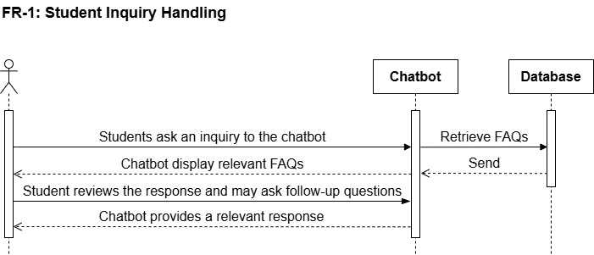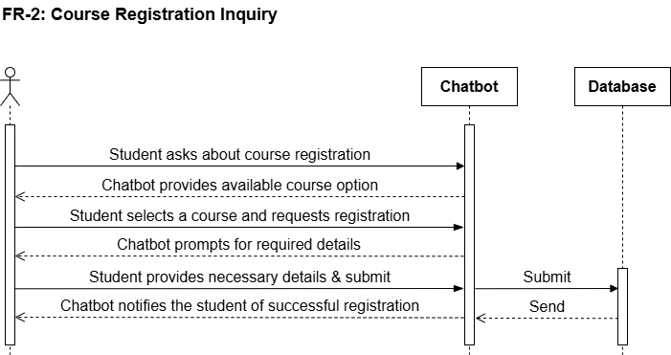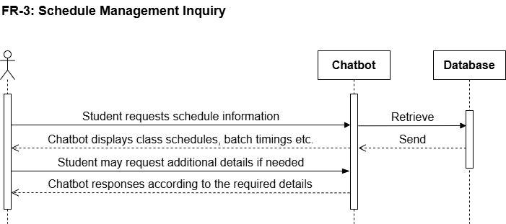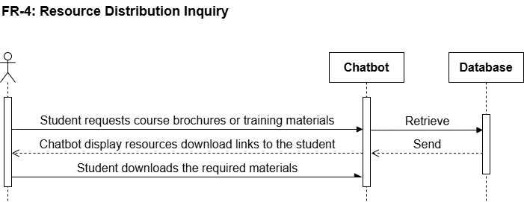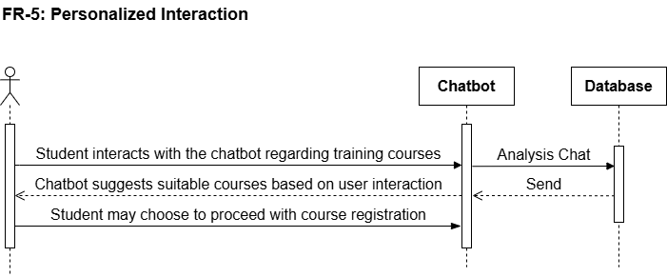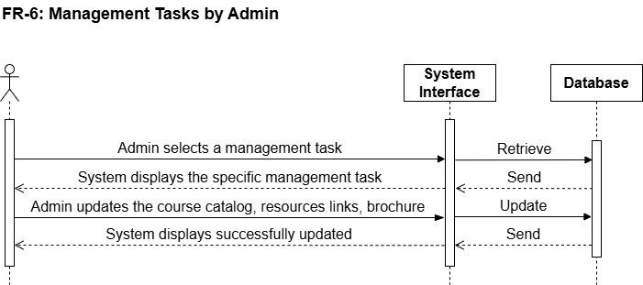

**Please turn to the next page!**

**3.6 Object Model/Logical Model: Class Diagram**

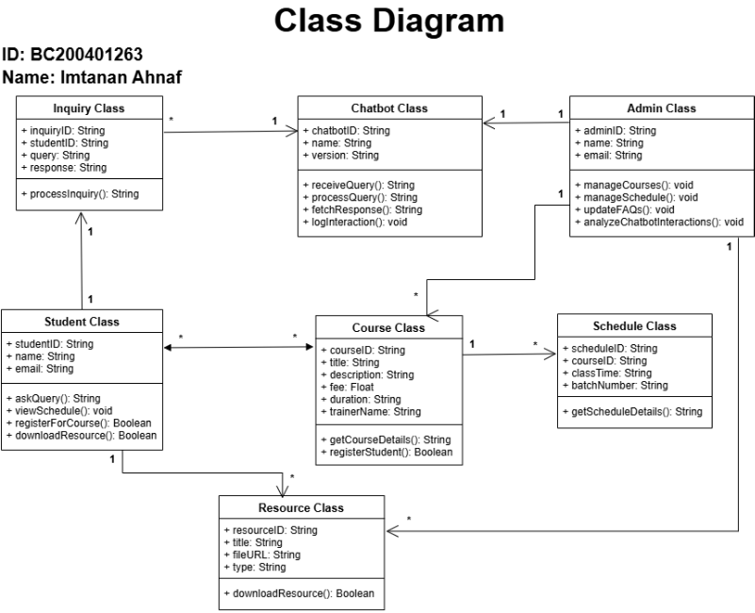

**Next page:-**

**3.7 Database Model(database diagram)**

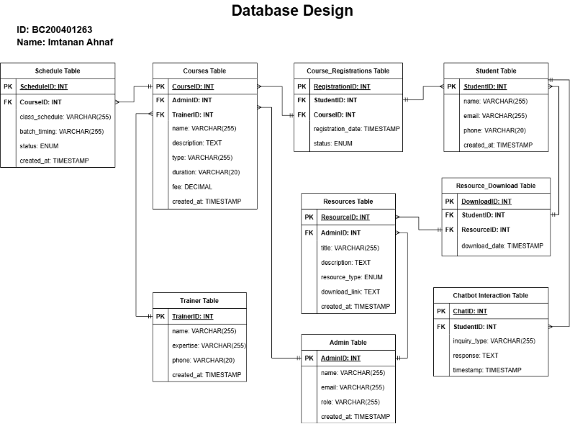

**NEXT PAGE:-**

**3.8 Graphical User Interfaces(GUI)**

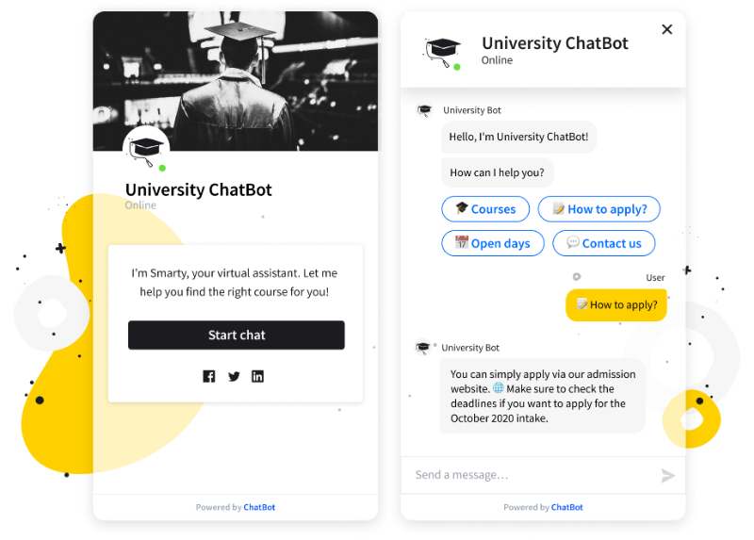

3.9 Intents Structure

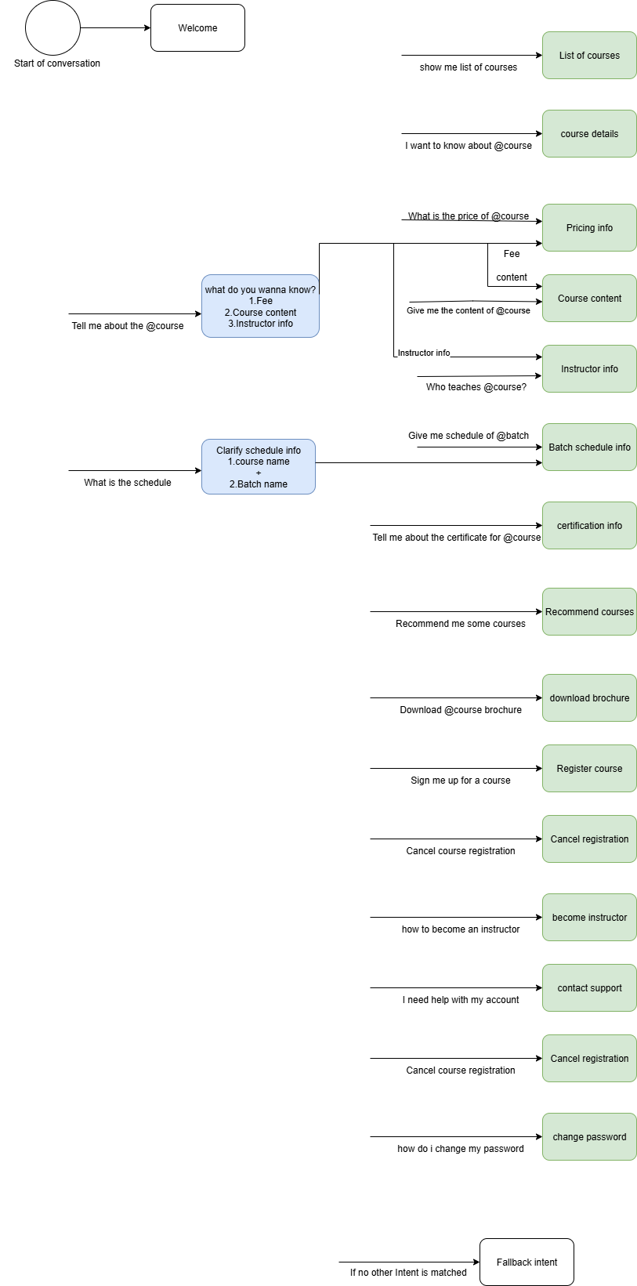

**CHAPTER 4**

Development

**Development Plan – Phased Approach**

**4.1 Development Plan(Architecture Diagram)**

**Phase 1: Requirement Gathering & Analysis**

**Duration:** 1 Week  
**Goals:**

* Conduct meetings with stakeholders (students, trainers, admin).
* Define detailed functional and non-functional requirements.
* Finalize system scope, tools (Dialogflow, Firebase, etc.), and roles.

**Deliverables:**

* Software Requirements Specification (SRS)
* Use Case Diagram
* Entity Relationship Diagram (ERD)

**Phase 2: System Design**

**Duration:** 1 Week  
**Goals:**

* Design the system architecture (3-Tier: Presentation, Business Logic, Data).
* Create UML diagrams: Class, Sequence, Activity Diagrams.
* Design database schema and tables.

**Deliverables:**

* Architecture Diagram
* Class Diagram
* Sequence Diagrams
* Database Design Document

**Phase 3: Chatbot Integration with Dialogflow**

**Duration:** 2 Weeks  
**Goals:**

* Design chatbot intents and entities for:
  + Course Inquiry
  + Registration Process
  + Schedule & Resource Inquiry
  + Personalized Recommendations
* Train and test the chatbot in Dialogflow.
* Enable chatbot response using webhook (Python/PHP API).

**Deliverables:**

* Fully functional chatbot with training phrases and responses
* Webhook integration (backend logic)

**Phase 4: Backend Development (Business Logic Layer)**

**Duration:** 2 Weeks  
**Goals:**

* Set up backend with RESTful API using Python (Flask/Django) or PHP.
* Implement core modules:
  + Student Management
  + Admin Management
  + Course Management
  + Resource & Schedule Management
  + Chatbot Interaction Logging

**Deliverables:**

* Fully developed backend with API endpoints
* Admin panel for managing data

**Phase 5: Frontend Development (Web Interface)**

**Duration:** 2 Weeks  
**Goals:**

* Develop web UI using HTML/CSS/JavaScript.
* Create user modules:
  + Student Registration/Login
  + Chatbot interface
  + Inquiry/Resource Viewer
* Integrate UI with backend via AJAX/API calls.

**Deliverables:**

* Responsive frontend web portal for users and admin
* Real-time chatbot interface

**Phase 6: Database Integration & Testing**

**Duration:** 1 Week  
**Goals:**

* Integrate database (MySQL/Firebase).
* Perform unit testing and integration testing.
* Validate chatbot responses and data flows.

**Deliverables:**

* Populated test database
* Test cases for modules
* Debugging & performance optimization

**Phase 7: Deployment & Maintenance**

**Duration:** 1 Week  
**Goals:**

* Deploy application to hosting server (e.g., Firebase Hosting, Heroku, or Localhost).
* Monitor performance, logs, and chatbot accuracy.
* Set up feedback mechanism for improvement.

**Deliverables:**

* Deployed application
* Documentation (User Manual + Developer Guide)
* Maintenance Plan

**NEXT page:-**

**Architecture Diagram**

**REFERENCES**

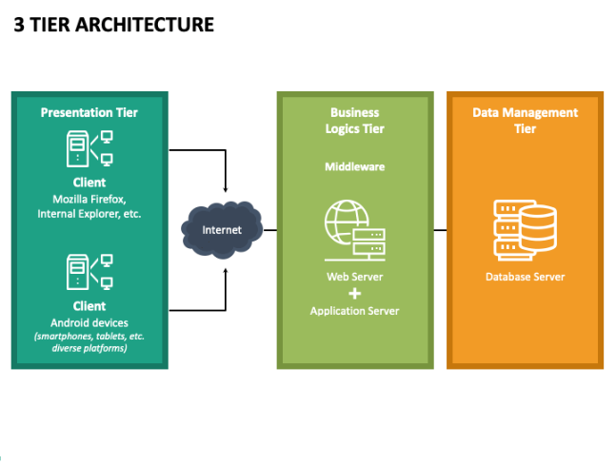

### **REFERENCES**

#### **Books and Journals:**

* Pressman, R. S., & Maxim, B. R. (2020). *Software Engineering: A Practitioner’s Approach* (9th ed.). McGraw-Hill Education.  
  *Covers software engineering models, requirements, and design strategies used in chatbot development.*
* Sommerville, I. (2016). *Software Engineering* (10th ed.). Pearson.  
  *Provides in-depth concepts on system design, architecture, and testing relevant to chatbot systems.*
* Date, C. J. (2019). *An Introduction to Database Systems* (8th ed.). Addison-Wesley.  
  *Essential reference for designing the chatbot’s relational database for user queries and responses.*
* Russell, S., & Norvig, P. (2021). *Artificial Intelligence: A Modern Approach* (4th ed.). Pearson.  
  *A foundational book for understanding NLP and AI techniques used in chatbot systems.*
* Jurafsky, D., & Martin, J. H. (2023). *Speech and Language Processing* (3rd ed.). Prentice Hall.  
  *Core text for NLP principles applied in chatbot communication and intent recognition.*

#### **Web Resources:**

* Google Cloud. (2024). *Dialogflow Documentation*. Retrieved from https://cloud.google.com/dialogflow/docs  
  *Official documentation for Dialogflow used to build the chatbot and manage intents and entities.*
* W3Schools. (2024). *PHP Tutorial*. Retrieved from <https://www.w3schools.com/php/>  
  *Guide to building backend APIs and handling data communication.*
* Mozilla Developer Network (MDN). (2024). *JavaScript Guide*. Retrieved from <https://developer.mozilla.org/en-US/docs/Web/JavaScript/Guide>  
  *Used for implementing chatbot UI interactions in the frontend.*
* Bootstrap. (2024). *Introduction to Bootstrap*. Retrieved from <https://getbootstrap.com/docs/5.3/getting-started/introduction/>  
  *Frontend framework used for designing chatbot and admin interfaces.*
* MySQL. (2024). *MySQL Documentation*. Retrieved from <https://dev.mysql.com/doc/>  
  *Guide for structuring and managing the chatbot’s database.*

#### **Software and Tools:**

* PhpStorm. (2024). *PhpStorm Documentation*. Retrieved from <https://www.jetbrains.com/phpstorm/documentation/>  
  *IDE used to develop backend logic and APIs.*
* XAMPP. (2024). *XAMPP Documentation*. Retrieved from <https://www.apachefriends.org/index.html>  
  *Local development environment used to run PHP and MySQL.*
* Postman. (2024). *API Testing Guide*. Retrieved from <https://www.postman.com/>  
  *Used for testing chatbot API endpoints.*
* GitHub. (2024). *GitHub Documentation*. Retrieved from <https://docs.github.com/en>  
  *Platform used for version control and project collaboration.*

#### **Academic Papers and Articles:**

* Lee, M., & Kim, J. (2022). *Designing Intelligent Chatbots using NLP and AI Techniques*. *International Journal of Computer Science & Information Technology*, 14(1), 45-60.  
  *Discusses chatbot architecture and NLP implementation.*
* Ali, S., & Ahmed, F. (2023). *Conversational Agents in E-Learning: Enhancing User Experience through Dialogflow*. *Journal of Educational Technology Systems*, 52(2), 100-118.  
  *Focuses on chatbots in training environments, relevant to the case study.*

#### **Technical Documents and Standards:**

* IEEE. (2014). *IEEE Standard for Software and System Test Documentation*. IEEE Std 829-2008.  
  *Standard used for writing and organizing test cases for chatbot validation.*
* W3C. (2018). *Web Content Accessibility Guidelines (WCAG) 2.1*. Retrieved from <https://www.w3.org/TR/WCAG21/>  
  *Ensures chatbot UI is accessible to all users.*

#### **Project Management:**

* Project Management Institute. (2017). *A Guide to the Project Management Body of Knowledge (PMBOK Guide)* (6th ed.). PMI.  
  *Provides structure for managing chatbot development phases, team tasks, and deliverables.*

#### **Miscellaneous:**

* Stack Overflow. (2024). *Various Discussions and Solutions*. Retrieved from <https://stackoverflow.com/>  
  *Community solutions used during project debugging and integration.*
* GitHub. (2024). *Chatbot Projects and Dialogflow Samples*. Retrieved from <https://github.com/>  
  *Reference for sample code and best practices in chatbot projects.*

**APPENDIX**